ME400 Capstone Design 1

Progress Report #1 (19th March ~ 25th March)

20140870

Bomi Lee

1. Overall Project

Until 19th of March, our group had brainstorming to select the picking mechanism. Also, we had thought about vibration and cooling system just based on the research material because we did not have any experience about them since battery is not provided yet.

During this week, we try to finalise our mechanism method and get some feedback from our professor about several picking systems. Based on the feedback that he gave us, we decide our picking mechanism as the combination of cage and valve.

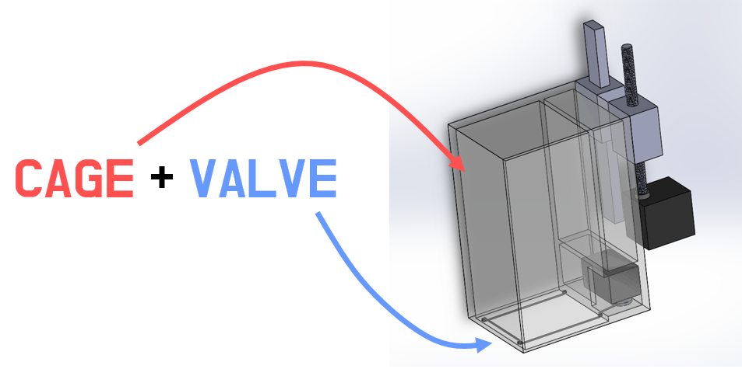

1. ROS

With ROS tutoring on 19th and 21st, I could finally understand how to make nodes and connect them as publisher and subscriber. Also, I learnt how to make one node into publisher and subscriber at the same time.

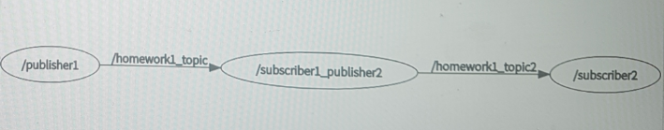

ME400 Capstone Design 1

Progress Report #2 (26th March ~ 1st April)

20140870

Bomi Lee

1. Overall Project

To get prepared for the 1st presentation on 30th of March, our team divide responsibilities into several categories. Our group showed rough idea to our professor and from that, we could get useful feedback especially about need for 2 cameras.

Also, we had refined our idea and organised the logics and reasons behind our choice. Especially, we used Pugh’s decision matrix method to analyse the fitness of picking mechanism to our project aim.

In addition, we conducted experiment to verify that our mechanism is actually working. Also, we try to eliminate possible errors and thus, decide to make the string adjustable.

1. ROS

For ROS, we had another TA session and from that, we learn how to connect Xbox with ROS and get data from that. Also, we connected rplidar to the get environment data which will be especially used to make a map. After that, we use Rviz to visualise the data and finally, learnt how to combine the data from rplidar and webcam.

Based on what we learnt, practice was carried out. Since this week, we focus more on deciding our system itself and preparing 1st presentation, I still need to work on ROS part in next week, too.

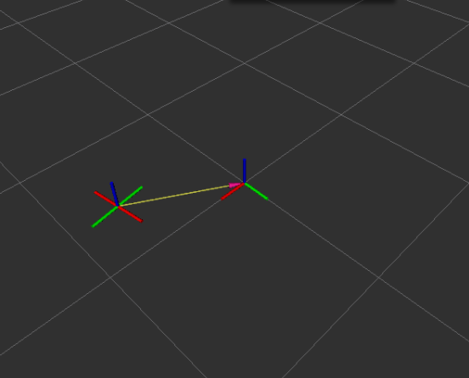

ME400 Capstone Design 1

Progress Report #3 (2nd April ~ 8th April)

20140870

Bomi Lee

1. Overall Project

Our group set the progress goals based on our schedule. Since we have midterm in next two weeks, we decide to make a rough prototype to test the speed of the motor and wheel with the load before next week.

The car body was made with aluminium profile and the wheel is attached to the dynamixel directly without any gearbox. Labview code linking the input in the xbox controller and the output which will be the input value to the dynamixel was made to control the bot with xbox controller. With xbox controller’s input of translating and rotating, our prototype moves well.

From this prototype, we concluded that the precise control of the direction can only be done in proper floor material; otherwise, the wheel slips which is not desired as the direction of the bot is determined by the angular speed ratio of the four wheel. Also, as the speed of the bot is not satisfied we are considering using gear box.

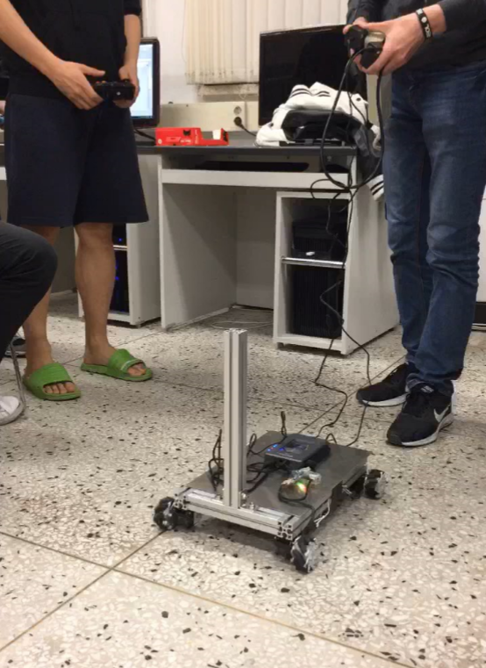

1. ROS

Progress goal for ROS was to use the rplidar information got in real time to display using RVIZ and get real coordination information, and find a proper package for the map. Since we had experience about how to use rplidar with RVIZ, getting information and displaying was not problem. However, we could not link the information with the package we found. We still need to working on this.

ME400 Capstone Design 1

Progress Report #4 (9th April ~ 15th April)

20140870

Bomi Lee

1. Overall Project

During the group meeting on 9th of April, we asked about the specification of the DC-DC convertor which will be used between the battery and our sub-devices such as NUC, dynamixel and MyRio. Before, we set the specification based on the sum of the stall current of the motors but we got the useful feedback from our TA that the motor does not operate at the high current as stall current. It is not problem to have higher current specification but as we have limited budget, we decided to have a step down convertor from 24V to 12V with current of 10A.

After the meeting, we did not have a regular meeting as we decide to focus more on the midterm exam this week. But we kept talking to each other using group chat room regarding the purchase of the material needed and schedule for next week.

1. ROS

Due to the limited storage space in the Ubuntu in our laptop, we started to move on to the NUC for our ROS project. As a monitor was provided to each group, we linked the monitor and our NUC to see the display output. Also, we use separate input devices such as keyboard and mouse to use NUC. We downloaded teamviewer program so that we can remote control the NUC even in our dorm rooms. From now on, the majority work of the ROS will be done using NUC.

We tried the package we found within NUC but still not working. We plan to figure it out before the 2nd presentation.

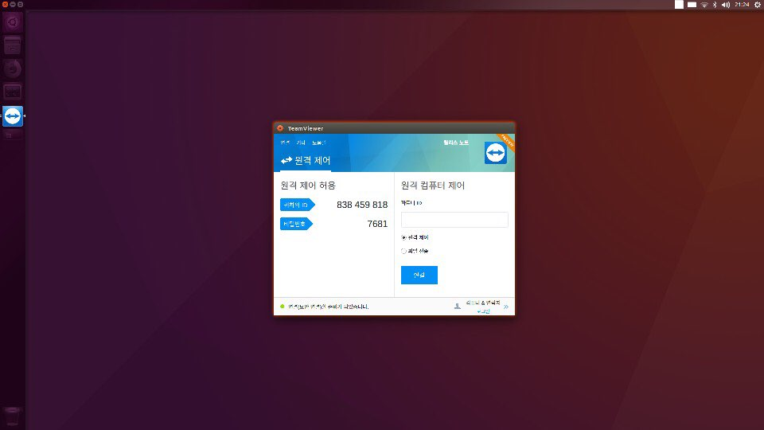

ME400 Capstone Design 1

Progress Report #5 (16th April ~ 22nd April)

20140870

Bomi Lee

1. Overall Project

During this week, we had done the soldering and configuration of the circuit. Since NUC takes 19V and dynamixel and myRIO take 12V as their input, we set one DC-DC convertor to step down the battery voltage output from 21.6V to 12V using 24V-12V convertor. Also, in order to make the connection easier, we made a wire with a 2-pin terminal connector (white) at the one end and a cable connector (black) at the other end as we can see from the second figure below.

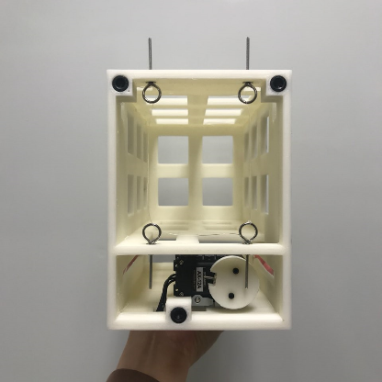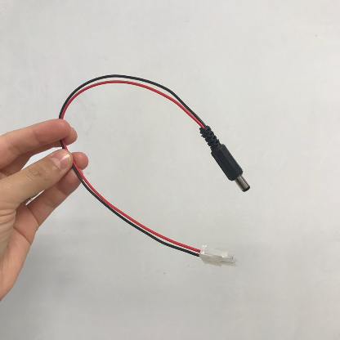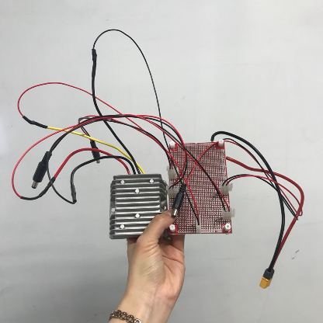Also, pick up part printed by 3D printer is refined more so that we can put motor and string to the pick up part.

1. ROS

During this week, not so much progress was made in ROS part because it was a midterm exam period.

For ROS part, there was a TA session on Friday. We could ask question about ROS code and got help from TA regarding problems we faced during the project. For our team, SLAM was the main problem. We tried Hector slam and gmapping and we concluded that gmapping is more suitable for our project. For the next few days, we are going to study more about SLAM.

ME400 Capstone Design 1

Progress Report #6 (23rd April ~ 29th April)

20140870

Bomi Lee

1. Overall Project

According to the goal we set, ROS and OpenCV worked for detecting one ball and moving toward the ball without xbox controller, and Solidworks and Labview worked for the implementation of pick-up part. The team is still working on the code that control the motors and making pick up part moved by the motor.

In addition to that, we had the second test that we controlled the mobile platform with xbox controller but this time, powered by actual battery. We could see that the circuit we made to give out proper power for each components worked well and the extent of the vibration when we attached the webcam and move the mobile platform. We still need to think about the need of vibration reducer and if it is needed, the way to implement the damping system into the mobile platform.

1. ROS

There were a few big progresses in this week. First of all, we made a node that integrate the OpenCV so that ROS can run the node and the corresponding outcome from the OpenCV can be delivered through ROS topic.

Also, transfer matrix was made to convert OpenCV result which is based on the camera coordinate into car body coordinate. By implementing the transfer matrix, we can get the coordinate relative to the car and this enables us to move the mobile platform with the information based on the camera. Since we did not set the whole configuration yet, we set the position of the camera attached to the mobile platform.

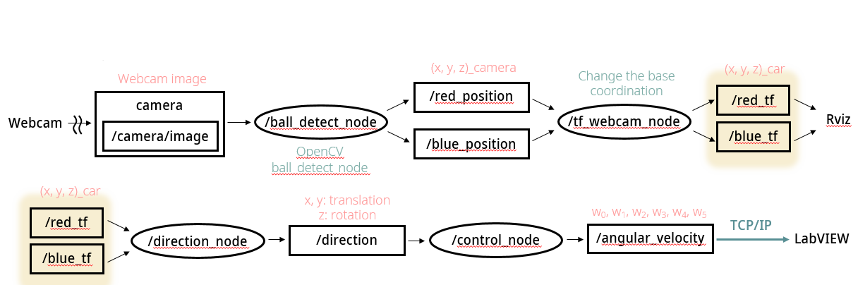We are now trying to make a node that subscribes the message that contains the result of the OpenCV and publishes the message about motor control input so that the car can move autonomously. So far, subscribing the message is done and need to work on the code that converts the image information into motor control input.

ME400 Capstone Design 1

Progress Report #7 (30th April ~ 6th May)

20140870

Bomi Lee

1. Overall Project

This Friday was the day of 2nd presentation and our goal till the presentation day was to control the mobile system automatically based on the visual result and pick up the ball with xbox controller.

Continued from the last week, we succeeded in controlling the mobile platform based on vision detection by integrating OpenCV code with ROS and sending the result to myRIO controlled by LabVIEW.

Also, as pick up part is accomplished by Solidworks, we first tested each motor for string and vertical movement of the whole pick up body with Labview and then implement to the mobile platform to perform the picking up.

In addition to that, we checked for the vibration and heat release problem with our mobile system. As we run our system, the vibration from the camera and the temperature change after running our mobile platform for 10 minutes were checked.

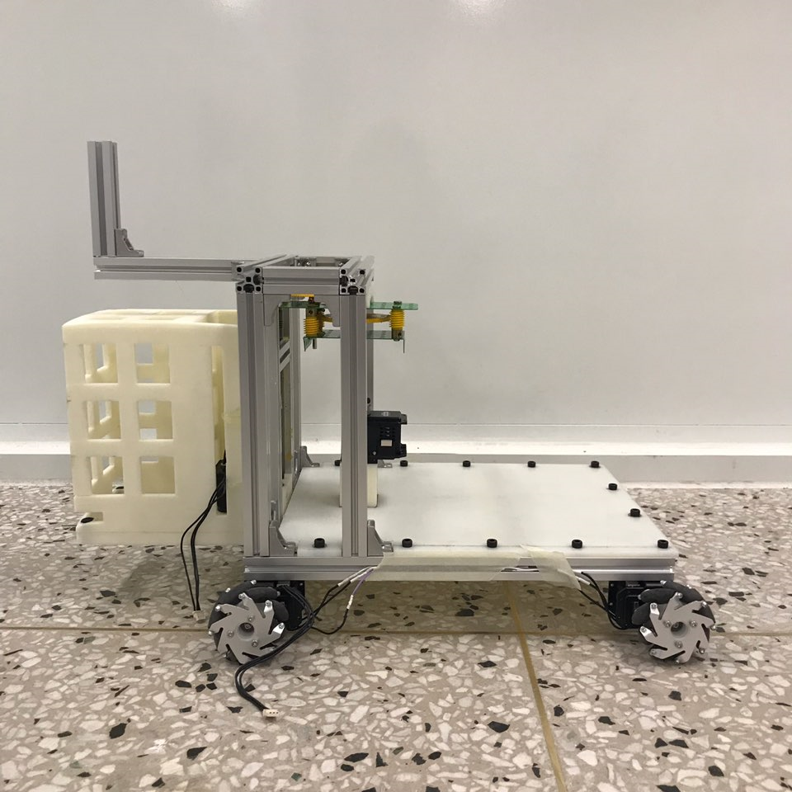 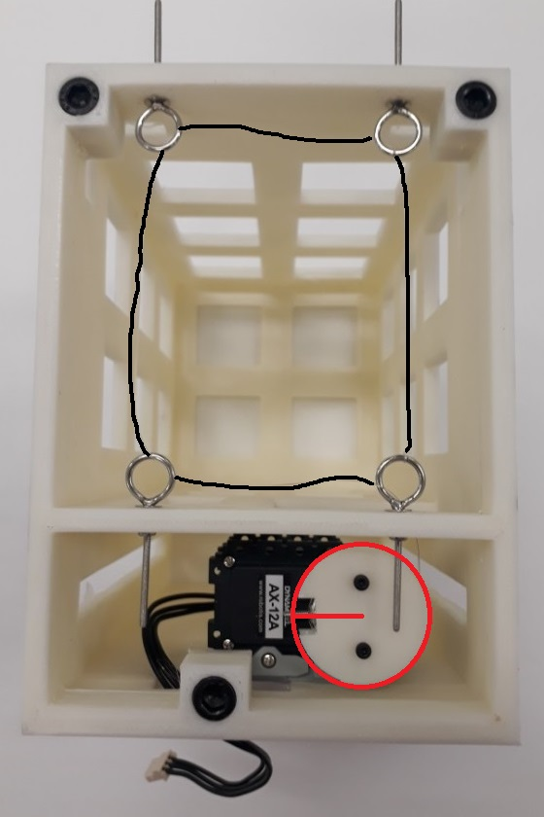 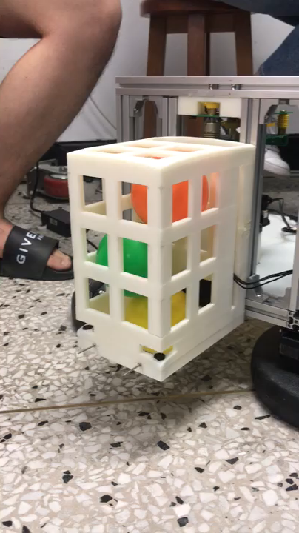 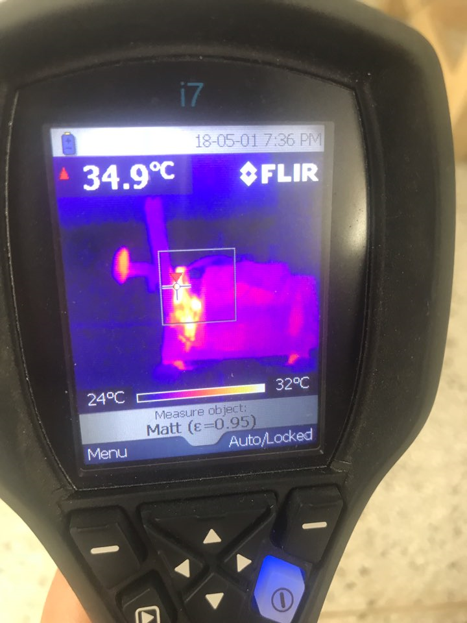

1. ROS

In order to accomplished two goals, ROS needed to do several tasks. First of all, we got the data from OpenCV and transformed with respect to the body coordinate so that the motor control can be done with respect to the car body. Then, calculate the direction that we have to move and send the motor input to the myRIO so that it can give the motor input that turns the car body to face the ball and move forward, approaching the ball. Now, we have to set our camera height and position to finalise our code.

ME400 Capstone Design 1

Progress Report #8 (7th May ~ 13th May)

20140870

Bomi Lee

1. Overall Project

We got the feedback from professors with our 2nd presentation and we planned for the next few weeks. First, we have to give more reasonable and specific reasons for not using any vibration suspension system. Also, we need to make an arrangement with professor to check with the thermal camera and make a best use of it.

Also, we decide to use bigger mecanum wheel to speed up our mobile platform without building any gearbox. We expect the bigger wheel to be not only faster but also more stable. Also, we discuss about the feasibility of passing over the red ball as the car height become much higher than before. As we ordered new wheel, we need to make a hub for new wheel and after finishing making hub, we will attach to the car body for testing including motor operation, vibration and heat problem.

1. ROS

What ROS need to do for next few weeks is that first, we need to re-set the transform matrix as we change the wheel and this changes the height of the car body. Also, we need to find the best height for the first camera that will detect the ball. The height is especially important for us as we have a pick-up part that will block the vision of the camera if camera is not hung at appropriate height.

In addition, as we will use bigger wheel, we need to do experiment with new wheel to find the optimised operation mechanism especially regarding the path. We still need to figure out that whether we have to avoid the red ball or we can just track the blue ball without any special algorithm to avoid the red ball.

Then, the algorithm for tracking and picking up the blue ball will be completed. So far, we can detect and track the blue ball by adjusting the angle between the camera and the ball. Also, since we do not have to be stay at rest while the pick-up part is moving up with ball trapped, we might be able to reduce the time by making upward vertical movement and tracking for the next ball simultaneously. This also need experiment to validate the feasibility.

ME400 Capstone Design 1

Progress Report #9 (14th May ~ 20th May)

20140870

Bomi Lee

1. Overall Project

This week, the bigger wheel was delivered and we need to make our own hub to connect the wheel and the motor as we decided not to buy the hub to save our budget. Thus, first we tried with aluminium round bar and use lathe to cut into desired radius and desired shape. We also needed to make three holes in regular triangle to fix it between wheel and the motor. As our professor suggested, we printed out the triangle within a circle size of our hub and glued it to make a punch hole over. However, the hub made had lots of inaccuracies so we tried with PVC. PVC is easier to process that we could use milling machine. After all, we could make hub.

Second thing we did in this week is that we get fan and transistor to implement the heat control system. We planned to get temperature of the dynamixel and this information will be send to myRIO, using that as an input for the fan. As a result, we could change the strength of the fan corresponding to the temperature of the fan. In order for that, we first soldered all the wires and transistor necessary to constitute the heat control system.

In addition to that, we had a vibration test to analyse the vibration of our system. We figured out that the peaks are existed at every one-quarter of the input frequency due to imperfect-circle-wheel’s rotation. This will be analysed further with the help from vibration professor’s advice. The gear box was changed to new one as the rotating axis was not aligned well and this kept exerting force on coupling that connect two axes.

1. ROS

For ROS, as we use bigger wheel, we no longer consider about the red ball. Indeed, with the bigger wheel, we can pass over the red ball. Also, code for the green ball detection was added so that we can approach to the basket point.

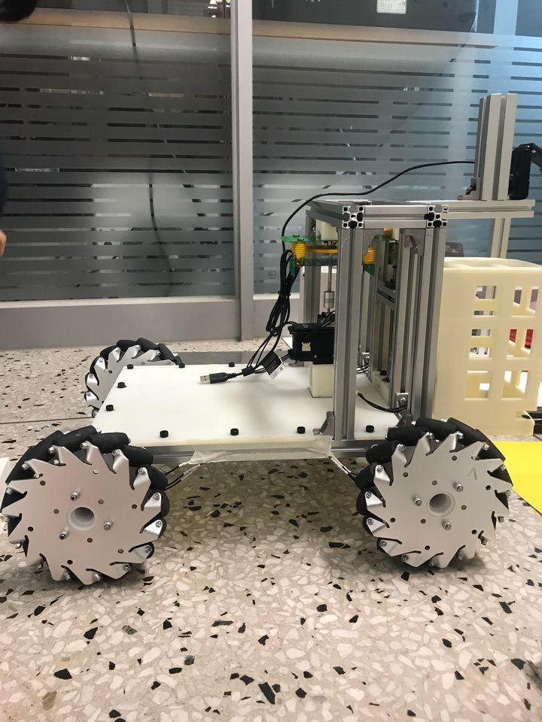

ME400 Capstone Design 1

Progress Report #10 (21st May ~ 27th May)

20140870

Bomi Lee

1. Overall Project

We tried to finalise our hardware. So, we set the camera angle that first and second camera co-work well without losing track of the blue ball. Also, we change the base plate of the Namsaeng-2 with changing the position of the bottom motor slightly to improve the axes alignment even more. Also, we added the vertical profile on the car frame so that we can put converter with most contact of the air and fix the position of the battery and other components such as myRIO and circuit board.

Also, as we adjust the angle of the camera, there was no enough space for the red ball to pass. So, we thought of two ways; increasing the height of the car frame or change the position of the camera. As raising the car might increase instability and we move the second camera backward. With trial and error, we found the best position and the angle of the camera that does not break the movement of the red ball.

1. ROS

One of the feedback we got was that our pick-up system is slower than other mechanism. In order to take the feedback, we change the code so that the car is searching for the next ball and starting to move right after the pick up part catches the ball. Thus, now when our pick-up part is moving upward, our Namsaeng-2 is start moving.

Also, as there was a data lag at starting point as data was sending as soon as the code is started. However, there is a certain amount of time needed for the system to be ready to operate. So we add another function that check the state of the Namsaeng-2 whether it is ready to operate or not. By adding this code, we can get rid of the data lag happened at the beginning of the operation.

Moreover, we will be going to use rplidar to check the wall and especially when it approached to the basket near the wall. We still need to improve the code but the skeleton of the code is ready to go.

ME400 Capstone Design 1

Progress Report #11 (28th May ~ 1st June)

20140870

Bomi Lee

1. Overall Project

We adjusted our Namsaeng-2 as we tried the demonstration in demo-room including the camera angle and tf code in ROS. Also, we finalise our configuration and set the target point for the fan. There are two biggest special points for our system. First one is the vibration reduction system. We decided to put vibration absorption system; but the special point is that we use battery as an absorber instead of additional mass that needed to put into the system to absorb the vibration. With this idea, we do not have to add additional mass to the system. The second point is that we use active control for our heat release system.

FAN control

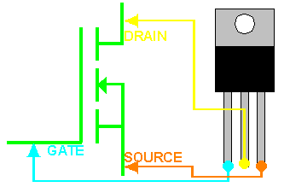

MOSFET

(switch)

5V: ON

0V: OFF

Temperature read by thermistor and thermometer in dynamixel

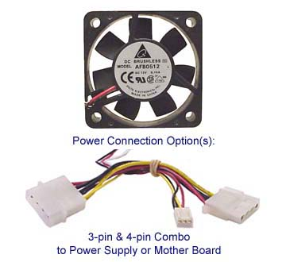

Use analog output and GND from myRIO

myRIO

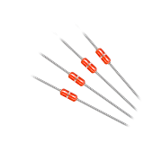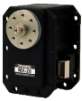

If over 40 °C

Battery

Car Body

Input Force

Input Force

<Vibration Reduction system>

<Active heat control system>

1. ROS

As we decide to put rplidar to approach the basket, we tried with the skeleton code. One of the problem was that if the distance is too far, the camera did not capture the green ball which indicates the basket. Hence, we use rplidar to place our car at the center of the demo field so that the second camera can catch the green ball and make the car approach the basket. Then by data from rplidar the Namsaeng-2 approached to the basket and using the distance from the wall, it finds the basket and dump the three balls.